BSSE FINAL PROJECT
Software Requirements Specification

PetLink



Product Owner

Zupash Awais

Presented by:
Group ID: S26SE025

Reg# No | Member Name
L1F22BSSE0286 | Nabeel Ijaz
L1F22BSSE0297 | Ehsan Shahid
L1S23BSSE0100 | Umar Akram
L1S23BSSE0089 | Usama

Faculty of Information Technology & Computer Science

University of Central Punjab

Software Requirements Specification

Version:1.3

Product Owner:

Zupash Awais

Scrum Master

Nabeel Ijaz

S26SE025

Team
Member Name | Roles
Nabeel Ijaz | Backend Development
Umar Akram | Web Development
Usama | Database Design and Testing
Ehsan Shahid | Mobile App Development

Table of Contents
Table of Contents i
Revision History & Sprint Log ii
Previous Phases Feedback ii
Abstract 1
1. Introduction and Background 2
1.1 Product Vision & Problem Context 2
1.2 Stakeholders Identification 4
2. Agile Framework Setup 5
2.1 Epics For the Project 6
2.2 Product Backlog 7
2.3 User Stories 9
2.4 Story Points & Estimation 12
2.5 Sprint Planning & Sprint Backlog 13
3. Functional Requirements 14
3.1 Use Case Diagram 14
3.1.1 Use Case Diagram Table 14
3.1.2 User Registration and Authentication 19
3.1.3 Manage User Profile 20
3.1.4 Create and Manage Pet Profile 20
3.1.5 Manage Pet Listing 21
3.1.6 Request Temporary Shelter Service 22
3.1.7 Purchase Pet Product 23
3.1.8 Manage Pet Health Records 24
3.1.9 Interact With AI Chatbot 25
3.1.10 Find Nearby Veterinary Clinics 26
3.1.11 Admin Store Management Diagram 27
4. Non-functional Requirements 28
4.1 Reliability 28
4.2 Performance 28
4.3 Use-ability 28
4.4 Other Non-functional Requirements 29
5. Scrum Activities Plan 30
5.1 Kanban Board / Task Tracking 30
5.2 Acceptance Criteria 31
5.3 Release Criteria 31
5.4 Burndown Chart & Progress Tracking 31
5.5 Backlog Refinement Plan 32
6. Risk Analysis 33
7. References 34
Appendix A: Glossary 35
Appendix B: IV & V Report 36

Revision History & Sprint Log
Version | Sprint | Date | Changes | Owner
1.0 | Sprint 1 | May 11, 2026 | Initial SRS Drafting; fixed missing User Research data & Use Case numbering | Nabeel Ijaz
1.1 | Sprint 1 | May 15, 2026 | Fixed User Story Acceptance Criteria & unallocated Story Points | Ehsan Shahid
1.2 | Sprint 2 | May 18, 2026 | Corrected template section migration anomalies and balanced sprint velocity planning formulas | Umer Akram

Previous Phases Feedback

Idea Defense Feedback (Screenshot)
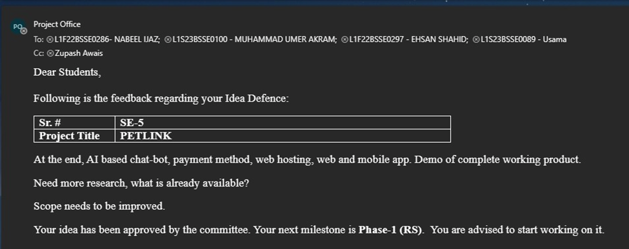

Abstract
PetLink is a cross-platform web and mobile application developed to serve as a comprehensive pet management platform. It provides a centralized digital solution for pet owners, adopters, buyers, and small service providers in Pakistan, enabling them to manage all pet-related activities through a single, user-friendly system.
In today’s fragmented environment, pet owners face significant challenges when they want to sell or adopt a pet, arrange temporary shelter during travel, purchase pet products, or maintain accurate health records. Most activities are currently handled through scattered social media groups, informal WhatsApp listings, or separate unconnected websites. This leads to incomplete information, lack of trust, difficulty in tracking vaccination schedules, unreliable service coordination, and increased risk of missing important pet care deadlines.
The proposed system offers a complete set of functionalities including user and pet profile management, pet adoption and sale listings with proper validation, temporary shelter service requests, an integrated pet product store with secure payment gateway, digital pet health and vaccination record management with automated reminders, Google Maps-based nearby veterinary clinic locator, and a custom AI-driven chatbot for instant user assistance and guidance.
By addressing these issues, PetLink fulfills a vital public need in the growing pet ownership community of Pakistan. It improves pet welfare through better record-keeping and timely care, enhances trust and transparency in pet trading and services, reduces fragmentation in the market, and provides a reliable, accessible platform that brings convenience and organization to thousands of pet lovers and service providers.

Introduction and Background

Product Vision & Problem Context
Problem Description:
Pet owners in Pakistan face numerous challenges in their daily lives while managing pet-related activities. When they want to sell or adopt a pet, they usually rely on scattered Facebook groups, WhatsApp chats, or random online posts where information is incomplete, unverified, and often misleading. Arranging temporary shelter for their pet during travel or work commitments becomes stressful because there is no reliable way to find trusted boarding services quickly. Purchasing pet food, accessories, or medicines requires visiting multiple websites or local stores with no centralized payment option. Moreover, keeping track of vaccination schedules, medical history, and important reminders is usually done manually on paper or phone notes, leading to missed doses and potential health risks for the pet. Overall, the lack of a single trusted platform forces users to switch between many unconnected sources, wasting time, reducing trust, and creating inefficiency in everyday pet care.
Target Users:
- Pet Owners / Adopters: Frequent users who need a simple and reliable interface to manage all pet-related activities.
- Service Providers (Shelters): Users who manage listings and provide shelter services.
- Platform Admin (Sellers): Manages platform content, resolves disputes, and ensures quality control and manage product listings.
Objectives of the System:
- To design and develop a cross-platform application providing a unified platform for all pet-related activities.
- To enable users to create and manage detailed pet profiles with adoption and sale listings.
- To provide a secure temporary shelter/boarding service request system.
- To implement an integrated pet product store with secure payment gateway.
- To develop a digital pet health and vaccination record management module with automated reminders.
- To integrate Google Maps API for location-based discovery of nearby veterinary clinics.
- To build an AI-driven chatbot for user assistance.
- To ensure responsive, user-friendly interface across web and mobile devices.
User Research:
To validate the real-world problems facing pet owners in Pakistan, our team conducted a quantitative user research survey utilizing Google Forms. The survey gathered detailed feedback from 24 active participants across the pet care community.
- Community Pet Ownership Rate: 70% of respondents currently own pets. Among pet owners, cats are the most common (71.4%), followed by birds and other pets.

- Market Fragmentation: 70% of users rely on scattered platforms including Facebook Groups, WhatsApp Groups, Instagram Pages, and OLX for pet-related activities. Only 10% use dedicated applications.

- Medical Record Struggle: 70% of respondents reported difficulty managing pet vaccination or medical records. Methods of tracking include phone notes, veterinary clinic records, paper records, and WhatsApp messages indicating no standardized solution.

- Demand for Automated Reminders: 80% of respondents stated that automated vaccination reminders would help them manage their pets better.

- Trust & Verification Concerns: Major problems identified when adopting or purchasing pets online include: fake/misleading information (40%), lack of trust (30%), no health records (30%), unverified sellers (10%), and scam concerns (10%).

- Shelter Service Challenges: Among users who have needed boarding services, common difficulties include: hard to find trusted providers (50%), lack of reviews (20%), expensive services (10%), and safety concerns (10%).

- Difficulty Finding Vets: On a scale of 1-5 (1 = easy, 5 = very difficult), responses averaged 2.9, indicating moderate difficulty finding nearby veterinary clinics quickly during emergencies.

- Demand for Centralized Platform: 90% of respondents said they would use or maybe use a single platform combining pet adoption, shopping, health tracking, and shelter services.

- AI Chatbot Interest: 70% of respondents expressed interest in using an AI chatbot for pet-related guidance.

- Verified Marketplace Importance: On a scale of 1-5 (1 = very important, 5 = not important), average response was 2.2, confirming strong demand for verified and trusted pet marketplaces.
Expected Benefits:
- Improved pet welfare through better record-keeping and timely care reminders.
- Enhanced trust and transparency in pet trading and services.
- Reduced fragmentation in the local pet management market.
- Convenient and centralized platform accessible on both web and mobile.
Potential beneficiaries:
- Direct beneficiaries: Pet owners, adopters in Pakistan.
- Indirect beneficiaries: Veterinary clinics, pet food suppliers, animal shelters, and the general pet welfare ecosystem.

Stakeholders Identification

Stakeholder | Role | Expectations
Pet Owner | Primary User | Easy-to-use interface; pet profile management, health tracking, service booking
Pet Adopters | Primary User | Verified listings, transparent adoption process
Pet Sellers | Primary User | Reach buyers, manage listings easily
Shelter Service Providers | Service Provider | Ability to post and manage Shelter Service listings; receive service requests, receive booking requests, manage availability communicate with users.
System Administrator | Platform Manager / Store Manager | Add/update/delete pet products, manage inventory, view orders, update order status, monitor activities, manage users
Store Manager | Product Manager | Upload product images, set prices, manage categories, handle stock levels
Zupash Awais | Product Owner / Supervisor | Project meets FYP requirements; proper documentation; functional system.
Scrum Master (Nabeel Ijaz) | Team Lead | Smooth sprint execution, remove impediments
Development Team | System Developers | Clear requirements; manageable workload; good tooling and support.
Investors/Business Partners | Financial Stakeholders | ROI, platform growth, market penetration

Agile Framework Setup
The PetLink project will follow the Agile Scrum methodology to manage development. Team roles, sprint durations, and tools are defined below.
Team Roles:
  - Product Owner: Zupash Awais (Supervisor)
  - Scrum Master: Nabeel Ijaz (Group Leader)
  - Development Team: Nabeel Ijaz, Ehsan Shahid, Muhammad Umar, Usama

Sprint duration:

Each sprint will last 2 weeks. The total project timeline is divided into multiple sprints covering all major feature modules.

Tools:

- Version Control: Git / GitHub
- Project Management: Jira (Kanban Board)
- Communication: WhatsApp Group, Weekly Meetings
- Documentation: Google Docs, Microsoft Word
- Development: VS Code, Postman, MongoDB Compass)
- Design: Figma
- Testing: Postman, Jest

Epics For the Project

Table of Epics:

Epic ID | Epic Name | Description | Related Problem Area
EP-01 | User Management | Handles user registration, login, authentication, profile management, and role-based access | Users unable to securely access the system
EP-02 | Pet Profile Management | Allows users to create, update, view, and delete pet profiles with images and details | No centralized pet information storage
EP-03 | Pet Marketplace (Adoption/Sale) | Manages pet adoption and sale listings with search, filter, and browse capabilities | Fragmented, unverified pet trading
EP-04 | Shelter Service Exchange | Handles temporary shelter/boarding service requests and management | No reliable pet boarding service coordination
EP-05 | Admin Product Management | Allows Admin to add, update, delete, and manage pet products with inventory, pricing, categories, and images | No centralized store management, manual product updates, inefficient inventory handling
EP-06 | User Product StoreFront | Allows users to browse products, add to cart, checkout, and purchase pet products | Disconnected pet product purchasing, no quality assurance
EP-07 | Payment Processing | Integrates payment methods and handles transaction processing | Lack of secure and automated payments
EP-08 | Order Management | Allows Admin to view customer orders, update order status (pending, shipped, delivered, cancelled), and manage order history | No order tracking, manual order processing
EP-09 | Digital Health Vault | Manages pet health records, vaccination schedules, and automated reminders | Missed vaccination schedules and health risks
EP-10 | AI Chatbot Assistant | Provides instant user assistance, guidance, and FAQs | No immediate help/support for users
EP-11 | Location Services | Integrates Google Maps for nearby veterinary clinic discovery | Difficulty finding vet clinics
EP-12 | Notification System | Sends alerts via in-app/push/email for important updates | Users miss important updates and reminders

Product Backlog

Product Backlog Table:
Backlog ID | Epic | Feature Description | Priority
PB-01 | User Management | Implement user registration with email and password | High
PB-02 | User Management | Develop secure login and logout functionality | High
PB-03 | User Management | Enable password reset and recovery via email | Medium
PB-04 | User Management | Create user profile management (view/update personal data) | Medium
PB-05 | User Management | Implement role-based access control (Admin/User roles) | Low
PB-06 | Pet Profile Management | Create pet profile with name, breed, age, weight, medical conditions | High
PB-07 | Pet Profile Management | Enable pet image upload and storage | Medium
PB-08 | Pet Profile Management | Allow edit and delete of pet profiles | Medium
PB-09 | Pet Marketplace (Adoption/Sale) | Create pet adoption listing with validation | High
PB-10 | Pet Marketplace (Adoption/Sale) | Create pet sale listing with price and details | High
PB-11 | Pet Marketplace (Adoption/Sale) | Implement search and filter for pet listings | High
PB-12 | Pet Marketplace (Adoption/Sale) | Display detailed listing view | Medium
PB-13 | Shelter Service Exchange | Create temporary shelter service request | Medium
PB-14 | Shelter Service Exchange | Manage shelter service listings by providers | Medium
PB-15 | Shelter Service Exchange | Implement request acceptance/rejection flow | Medium
PB-16 | Admin Product Management | Admin login with role-based access to admin dashboard | High
PB-17 | Admin Product Management | Admin can add new pet products (name, description, price, stock quantity, category, images) | High
PB-18 | Admin Product Management | Admin can view all products with search and filter | High
PB-19 | Admin Product Management | Admin can update existing product details (price, description, stock, images) | High
PB-20 | Admin Product Management | Admin can delete/disable products (soft delete) | Medium
PB-21 | Admin Product Management | Admin can manage product categories (add, edit, delete categories like Food, Accessories, Medicines, Toys) | Medium
PB-22 | Admin Product Management | Admin can upload multiple product images per product | Medium
PB-23 | Admin Product Management | Admin can set and update product inventory/stock levels | High
PB-24 | Admin Product Management | Admin can mark products as "Out of Stock" when inventory reaches zero | Medium
PB-25 | Order Management | Admin can view all customer orders with details | High
PB-26 | Order Management | Admin can update order status (Pending → Processing → Shipped → Delivered → Cancelled) | High
PB-27 | Order Management | Admin can view order history and sales reports | Medium
PB-28 | Order Management | Admin can track total revenue and product-wise sales | Medium
PB-29 | User Product Store | Users can browse pet products with categories | High
PB-30 | User Product Store | Users can search products by name, category, price range | High
PB-31 | User Product Store | Users can add products to shopping cart | High
PB-32 | User Product Store | Users can manage cart (update quantity, remove items) | Medium
PB-33 | User Product Store | Users can proceed to checkout with order summary | High
PB-34 | User Product Store | Users can view order history and track order status | Medium
PB-35 | User Product Store | Users can view product details (images, description, price, stock availability) | Medium
PB-36 | User Product Store | Checkout process with order summary | High
PB-37 | Payment Processing | Integrate payment gateway | High
PB-38 | Payment Processing | Process payments securely | High
PB-39 | Payment Processing | Handle payment success/failure scenarios | Medium
PB-40 | Digital Health Vault | Add vaccination/health records for pets | High
PB-41 | Digital Health Vault | View health records history | Medium
PB-42 | Digital Health Vault | Set and send automated reminders for due dates | High
PB-43 | AI Chatbot Assistant | Implement AI chatbot interface | High
PB-44 | AI Chatbot Assistant | Train chatbot on FAQs and platform guidance | Medium
PB-45 | AI Chatbot Assistant | Handle unrecognized queries gracefully | Medium
PB-46 | Location Services | Integrate Google Maps API | Medium
PB-47 | Location Services | Display nearby veterinary clinics based on location | Medium
PB-48 | Notification System | Implement in-app notifications | Medium
PB-49 | Notification System | Send email/push notifications for reminders and updates | Low

User Stories
User Story Board
Story ID | Backlog ID | User Story | Priority | Acceptance Criteria | Focal Person responsible for this task
US-01 | PB-01 | As a user, I want to register an account so that I can access the system | High | User enters valid data → account created successfully | Ehsan Shahid
US-02 | PB-02 | As a registered user, I want to log in securely so that I can access my account | High | Valid credentials → login success, Invalid → error message | Ehsan Shahid
US-03 | PB-03 | As a user, I want to reset my password so that I can regain access if I forget it | Medium | Email verification → password reset link sent | Nabeel Ijaz
US-04 | PB-04 | As a user, I want to update my profile information so that my details stay current | Medium | Save changes → profile updated successfully | Nabeel Ijaz
US-05 | PB-06 | As a pet owner, I want to create a profile for my pet so that I can manage all pet-related activities | High | Form submitted → pet profile created and saved | Umer Akram
US-06 | PB-09 | As a pet owner, I want to list my pet for adoption so that I can find a new home for them | High | Listing created → appears in marketplace | Ehsan Shahid
US-07 | PB-10 | As a pet owner, I want to list my pet for sale so that I can find potential buyers | High | Listing created with price → appears in marketplace | Nabeel Ijaz
US-08 | PB-11 | As an adopter, I want to search and filter pet listings so that I can find pets matching my preferences | High | Filters applied → relevant listings displayed | Nabeel Ijaz
US-09 | PB-13 | As a pet owner, I want to request temporary shelter so that my pet is cared for during my travel | Medium | Request submitted → notification sent to provider | Ehsan Shahid
US-10 | PB-36 | As a buyer, I want to purchase pet products securely so that I can get food and supplies delivered | High | Payment successful → order created and confirmed | Ehsan Shahid
US-11 | PB-40 | As a pet owner, I want to add vaccination records so that I can track my pet's health | High | Record added → saved with next due date | Nabeel Ijaz
US-12 | PB-42 | As a pet owner, I want to receive reminders for upcoming vaccinations so that I don't miss them | High | Due date reached → notification sent | Ehsan Shahid
US-13 | PB-43 | As any user, I want to chat with an AI assistant so that I can get instant help and guidance | High | Question asked → relevant response provided | Nabeel Ijaz
US-14 | PB-47 | As a pet owner, I want to find nearby veterinary clinics so that I can take my pet for emergency care | Medium | Location allowed → clinics shown on map | Ehsan Shahid
US-15 | PB-48,  PB-49 | As a user, I want to receive notifications about my requests so that I stay updated | Medium | Status change → notification received | Ehsan Shahid
US-16 | PB-16 | As an Admin, I want to log in to an admin dashboard so that I can manage the pet store | High | Admin credentials → dashboard access; non-admin → access denied | Nabeel Ijaz
US-17 | PB-17 | As an Admin, I want to add new pet products so that users can browse and purchase them | High | Form submitted with valid data → product saved and visible to users | Nabeel Ijaz
US-18 | PB-18 | As an Admin, I want to view all products so that I can manage inventory | High | Products displayed in table/grid with search and filter | Nabeel Ijaz
US-19 | PB-19 | As an Admin, I want to update product details so that I can change prices or descriptions | High | Changes saved → product updated in store | Nabeel Ijaz
US-20 | PB-20 | As an Admin, I want to delete/disable products so that I can remove items no longer available | Medium | Product disabled → not visible to users | Nabeel Ijaz
US-21 | PB-21 | As an Admin, I want to manage product categories so that products are organized properly | Medium | Category added/edited/deleted → products categorized correctly | Umer Akram
US-22 | PB-22 | As an Admin, I want to upload multiple product images so that users can see product details | Medium | Images uploaded → displayed on product page | Umer Akram
US-23 | PB-23 | As an Admin, I want to set inventory levels so that I can track stock | High | Stock set → auto "Out of Stock" when zero | Ehsan Shahid
US-24 | PB-25 | As an Admin, I want to view all customer orders so that I can process them | High | Orders displayed with customer details and items | Ehsan Shahid
US-25 | PB-26 | As an Admin, I want to update order status so that customers know their order progress | High | Status changed → notification sent to customer | Ehsan Shahid
US-26 | PB-27 | As an Admin, I want to view sales reports so that I can track revenue | Medium | Reports generated with total sales and product performance | Ehsan Shahid
US-27 | PB-29 | As a user, I want to browse pet products so that I can buy food and supplies | High | Products displayed by categories with images and prices | Ehsan Shahid
US-28 | PB-30 | As a user, I want to search for products so that I can find specific items | High | Search results relevant to keywords | Ehsan Shahid
US-29 | PB-35 | As a user, I want to view product details so that I can make informed purchase decisions | High | Product page shows all details including stock status | Umer Akram
US-30 | PB-31 | As a user, I want to add products to cart so that I can buy multiple items | High | Item added → cart updated with quantity | Umer Akram
US-31 | PB-32 | As a user, I want to manage my cart so that I can change quantities or remove items | Medium | Cart reflects changes correctly | Ehsan Shahid
US-32 | PB-36 | As a user, I want to checkout securely so that I can complete my purchase | High | Checkout → payment processing → order confirmed | Ehsan Shahid
US-33 | PB-34 | As a user, I want to view my order history so that I can track my purchases | Medium | Past orders displayed with status | Umer Akram

Story Points & Estimation

Story Point Estimation Table

Story ID | User Story (Short) | Complexity Level | Story Points | Justification
US-01 | User Registration | Medium | 3 | Requires form validation, database storage, and error handling
US-02 | User Login | Medium | 3 | Authentication logic and session handling required
US-03 | Password Reset | Medium | 3 | Email service integration, token generation
US-04 | Profile Update | Low | 2 | CRUD operations, form handling
US-05 | Pet Profile Creation | Medium | 3 | Image upload, data validation, relationships
US-06 | Pet Adoption Listing | Medium | 3 | Validation, marketplace integration
US-07 | Pet Sale Listing | Medium | 3 | Price validation, marketplace integration
US-08 | Search & Filter | High | 8 | Multiple filter criteria, search algorithm
US-09 | Shelter Request | Medium | 3 | Request flow, notification system
US-10 | Purchase Products | High | 8 | Cart, payment gateway, order processing
US-11 | Add Health Records | Low | 2 | CRUD operations, date tracking
US-12 | Vaccination Reminders | Medium | 3 | Scheduling system, notification service
US-13 | AI Chatbot | High | 13 | NLP integration, training, conversation handling
US-14 | Nearby Clinics | Medium | 3 | Google Maps API integration, location services
US-15 | Notifications | Medium | 3 | Real-time/in-app notifications
US-16 | Admin Login | Low | 2 | Role-based access
US-17 | Add Product | Medium | 3 | Multi-field form, image upload
US-18 | View Products | Medium | 3 | Table with search/filter
US-19 | Update Product | Medium | 3 | Edit form, save changes
US-20 | Delete/Disable Product | Low | 2 | Soft delete logic
US-21 | Manage Categories | Low | 2 | CRUD for categories
US-22 | Upload Product Images | Medium | 3 | Multiple image handling
US-23 | Set Inventory Levels | Low | 2 | Stock tracking
US-24 | View Orders | Medium | 3 | Order listing with details
US-25 | Update Order Status | Medium | 3 | Status workflow
US-26 | Sales Reports | Medium | 3 | Analytics, charts
US-27 | Browse Products | Medium | 3 | Storefront UI
US-28 | Search Products | Medium | 3 | Search implementation
US-29 | Product Details | Low | 2 | Detail page
US-30 | Add to Cart | Medium | 3 | Cart state management
US-31 | Manage Cart | Medium | 3 | Quantity updates
US-32 | Checkout | High | 8 | Multi-step process
US-33 | Order History | Low | 2 | History display

Sprint Planning & Sprint Backlog
Sprint Planning Table
Sprint No. | Duration | Sprint Goal | Total Story Points
Sprint 1 | 2 Weeks | Implement user authentication features | 13
Sprint 2 | 2 Weeks | Pet profile and marketplace core | 11
Sprint 3 | 2 Weeks | Shelter service and health records | 14
Sprint 4 | 2 Weeks | Admin Product Management (Store Backend) | 16
Sprint 5 | 2 Weeks | User Store & Order Management | 17
Sprint 6 | 2 Weeks | AI Chatbot and location services | 16
Sprint 7 | 2 Weeks | Admin Order Management & Reporting | 16
Sprint 8 | 2 Weeks | Testing, bug fixes, integration, polish | 14

Total Story Points:

Total Story Points: 13 + 11 + 14 + 16 + 17 + 16 + 16 + 14 = 117 points

Functional Requirements

Use Case Diagram

Use Case Diagram Table

Use Case ID | Use Case Name | Primary Actor | Description | Mapped User Story ID | User Story
UC-01 | User Registration | New User | Allows a new user to create an account using email and password | US-01 | As a new user, I want to register an account so that I can access the system.
UC-02 | User Login | Registered User | Enables users to log into the system securely | US-02 | As a registered user, I want to log in securely so that I can access my account.
UC-03 | Password Recovery | User | Allows users to reset their password via email verification | US-03 | As a user, I want to reset my password so that I can regain access if I forget it.
UC-04 | Manage User Profile | Registered User | View and update profile information | US-04 | As a user, I want to update my profile information so that my details stay current
UC-05 | Create & Manage Pet Profile | Pet Owner | Create, update, view, delete pet profiles | US-05 | As a pet owner, I want to create a profile for my pet so that I can manage all pet-related activities
UC-06 | Manage Pet Listing | Pet Owner | Create adoption/sale listings | US-06, US-07 | As a pet owner, I want to list my pet for adoption so that I can find a new home for them
UC-07 | Search & Browse Listings | Adopter/Buyer | Search, filter, view pet listings | US-08 | As an adopter, I want to search and filter pet listings so that I can find pets matching my preferences.
UC-08 | Request Shelter Service | Pet Owner | Request temporary shelter/boarding | US-09 | As a pet owner, I want to request temporary shelter so that my pet is cared for during my travel
UC-09 | Purchase Pet Product | Buyer | Browse cart, checkout, pay for products | US-10 | As a buyer, I want to purchase pet products securely so that I can get food and supplies delivered
UC-10 | Manage Health Records | Pet Owner | Add, view vaccination/health records | US-11 | As a pet owner, I want to add vaccination records so that I can track my pet's health
UC-11 | Receive Health Reminders | Pet Owner | Get automated reminders for due dates | US-12 | As a pet owner, I want to receive reminders for upcoming vaccinations so that I don't miss them
UC-12 | Interact with AI Chatbot | Any User | Chat with AI assistant for help | US-13 | As any user, I want to chat with an AI assistant so that I can get instant help and guidance
UC-13 | Find Nearby Clinics | Pet Owner | Locate veterinary clinics on map | US-14 | As a pet owner, I want to find nearby veterinary clinics so that I can take my pet for emergency care
UC-14 | Receive Notifications | User | Get updates on requests and reminders | US-15 | As a user, I want to receive notifications about my requests so that I stay updated
UC-15 | Admin Login | Admin | Secure login to admin dashboard | US-16 | As an Admin, I want to log in to an admin dashboard so that I can manage the pet store
UC-16 | Add Pet Product | Admin | Add new product with details, price, stock, images | US-17 | As an Admin, I want to add new pet products so that users can browse and purchase them
UC-17 | View All Products | Admin | View product list with search/filter | US-18 | As an Admin, I want to view all products so that I can manage inventory
UC-18 | Update Product | Admin | Edit product details, price, stock | US-19 | As an Admin, I want to update product details so that I can change prices or descriptions
UC-19 | Delete/Disable Product | Admin | Remove or hide products from store | US-20 | As an Admin, I want to delete/disable products so that I can remove items no longer available
UC-20 | Manage Categories | Admin | Add, edit, delete product categories | US-21 | As an Admin, I want to manage product categories so that products are organized properly
UC-21 | Manage Inventory | Admin | Update stock levels, mark out of stock | US-22, US-23 | As an Admin, I want to set inventory levels so that I can track stock
UC-22 | View Customer Orders | Admin | See all orders with details | US-24 | As an Admin, I want to view all customer orders so that I can process them
UC-23 | Update Order Status | Admin | Change order status (Pending→ Shipped→ Delivered) | US-25 | As an Admin, I want to update order status so that customers know their order progress
UC-24 | View Sales Reports | Admin | Generate revenue and product performance reports | US-26 | As an Admin, I want to view sales reports so that I can track revenue
UC-25 | Browse Products | User | View products by category | US-27 | As a user, I want to browse pet products so that I can buy food and supplies
UC-26 | Search Products | User | Search by name, category, price | US-28 | As a user, I want to search for products so that I can find specific items
UC-27 | View Product Details | User | See product images, description, price, stock | US-29 | As a user, I want to view product details so that I can make informed purchase decisions
UC-28 | Add to Cart | User | Add products to shopping cart | US-30 | As a user, I want to add products to cart so that I can buy multiple items
UC-29 | Manage Cart | User | Update quantity, remove items | US-31 | As a user, I want to manage my cart so that I can change quantities or remove items
UC-30 | Checkout | User | Place order and make payment | US-32, US-10 | As a user, I want to checkout securely so that I can complete my purchase
UC-31 | View Order History | User | Track past orders and status | US-33 | As a user, I want to view my order history so that I can track my purchases

Use Case Diagrams

User Registration and Authentication

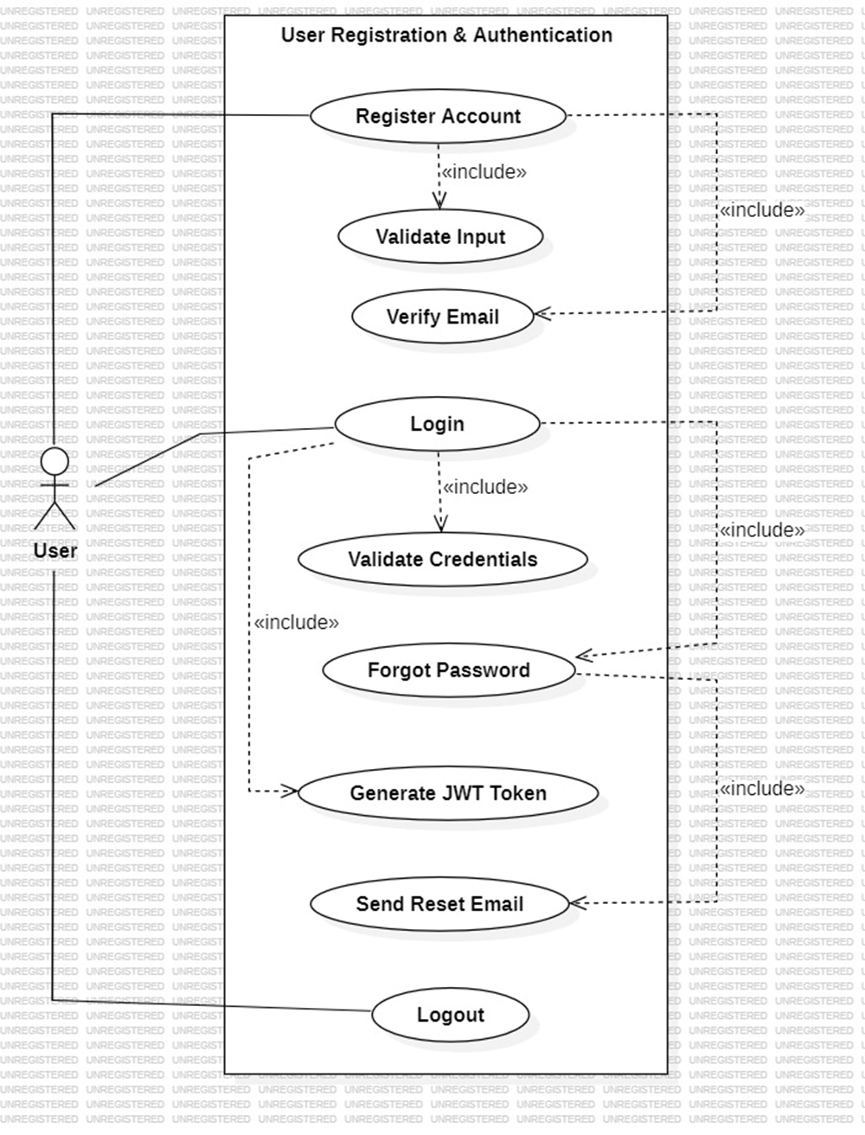

Manage User Profile
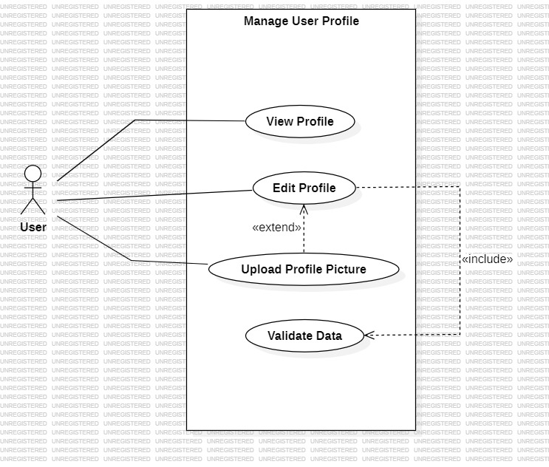

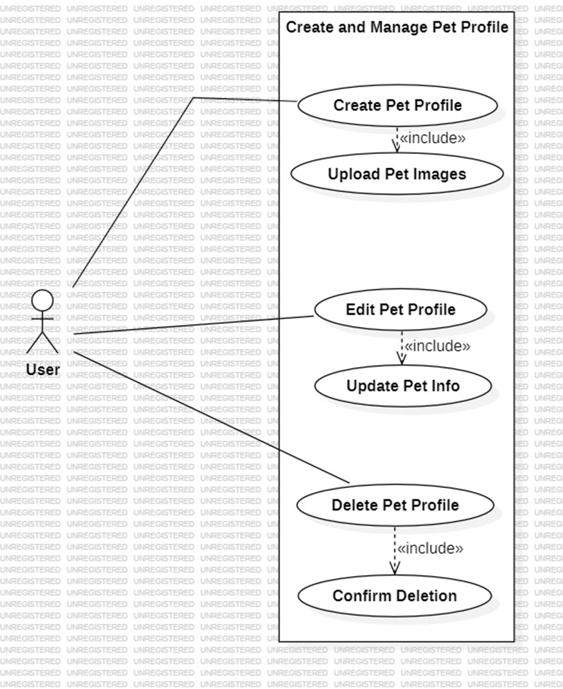
Create and Manage Pet Profile

Manage Pet Listing

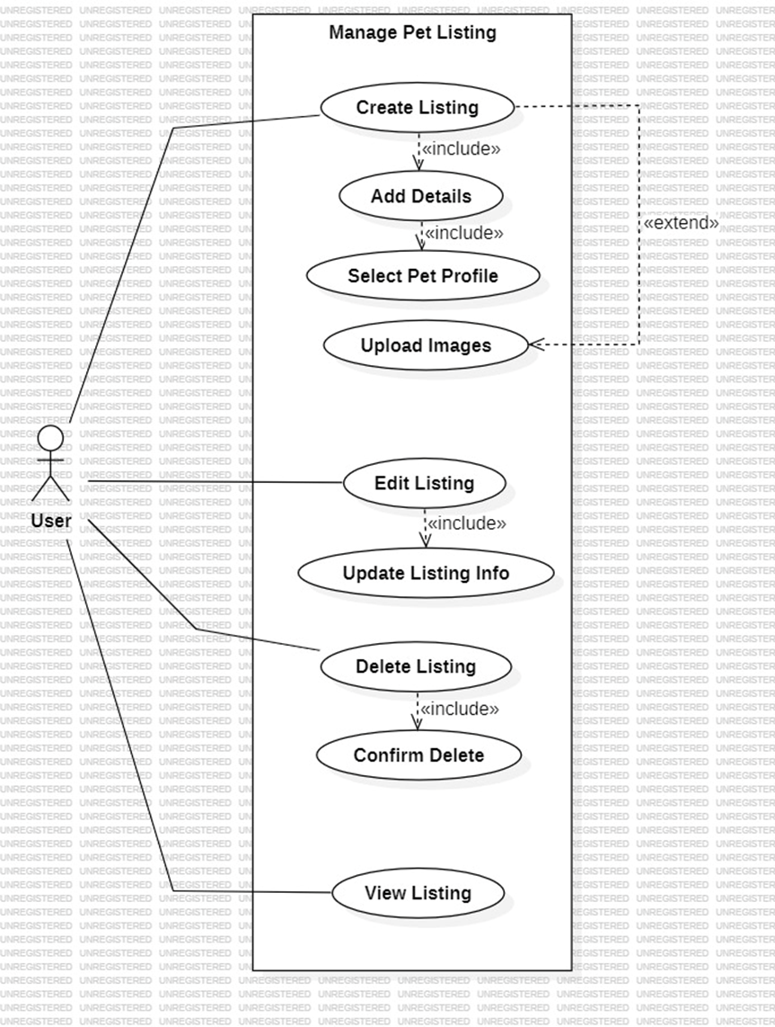

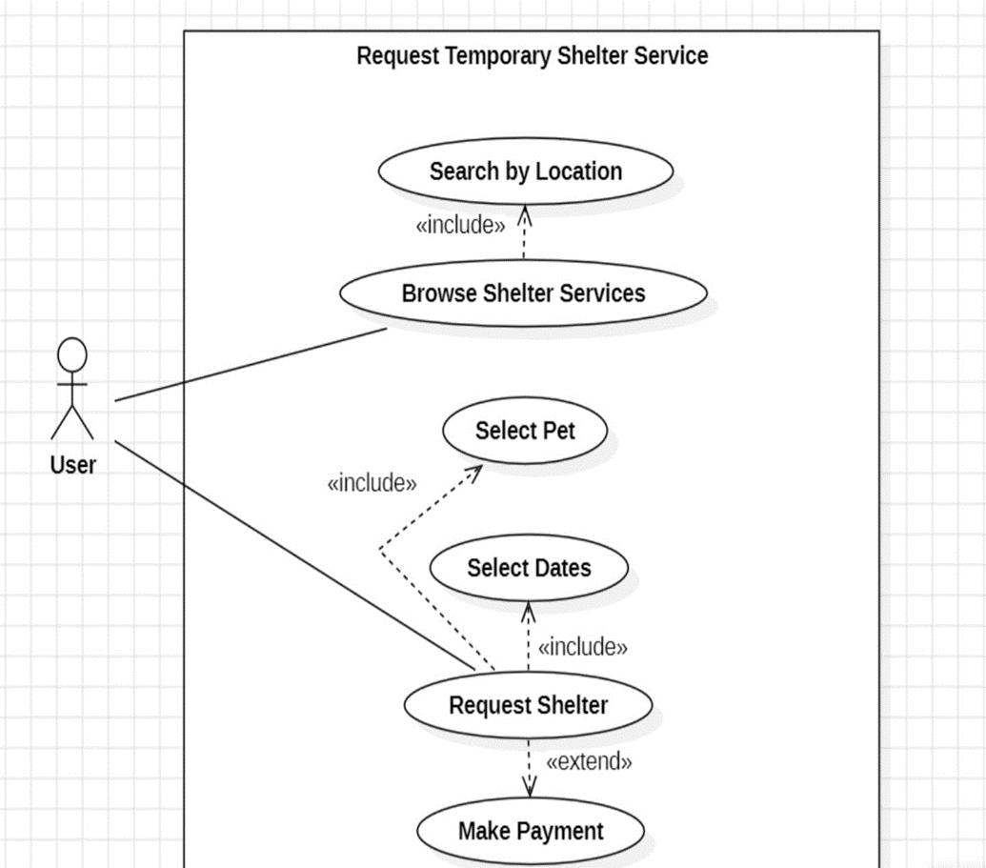
Request Temporary Shelter Service

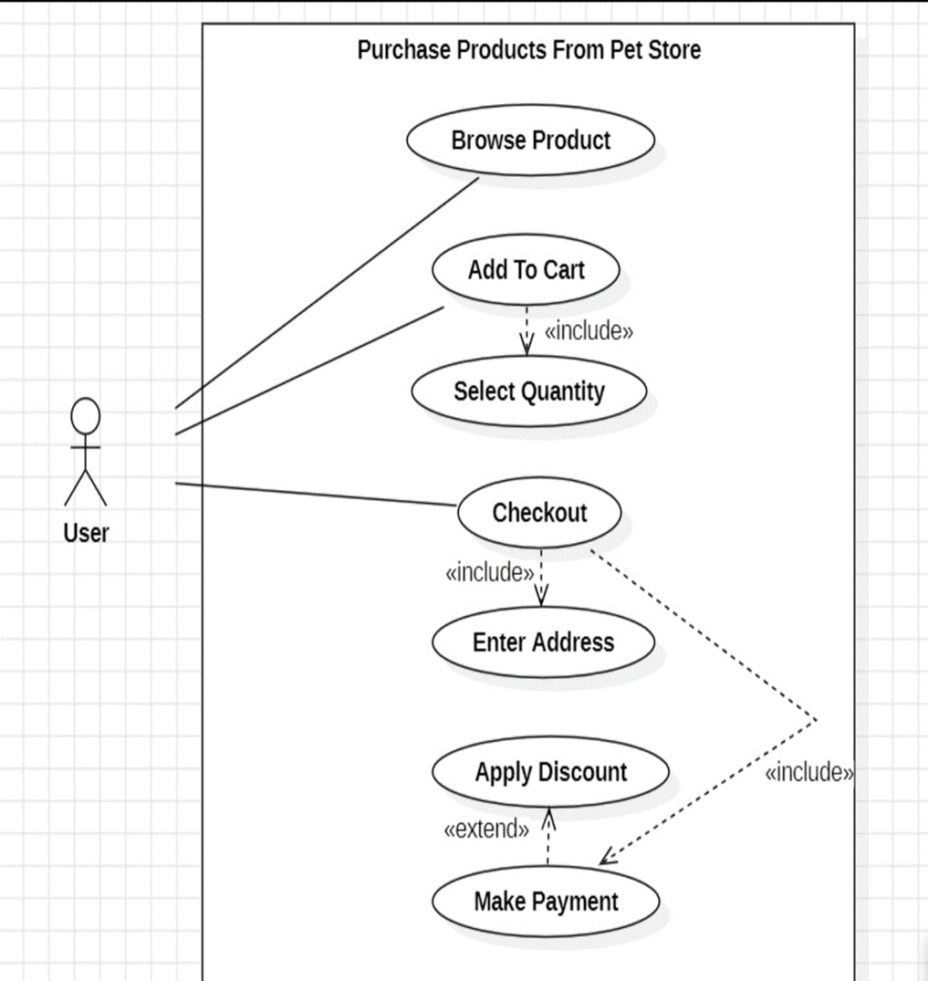
Purchase Pet Product

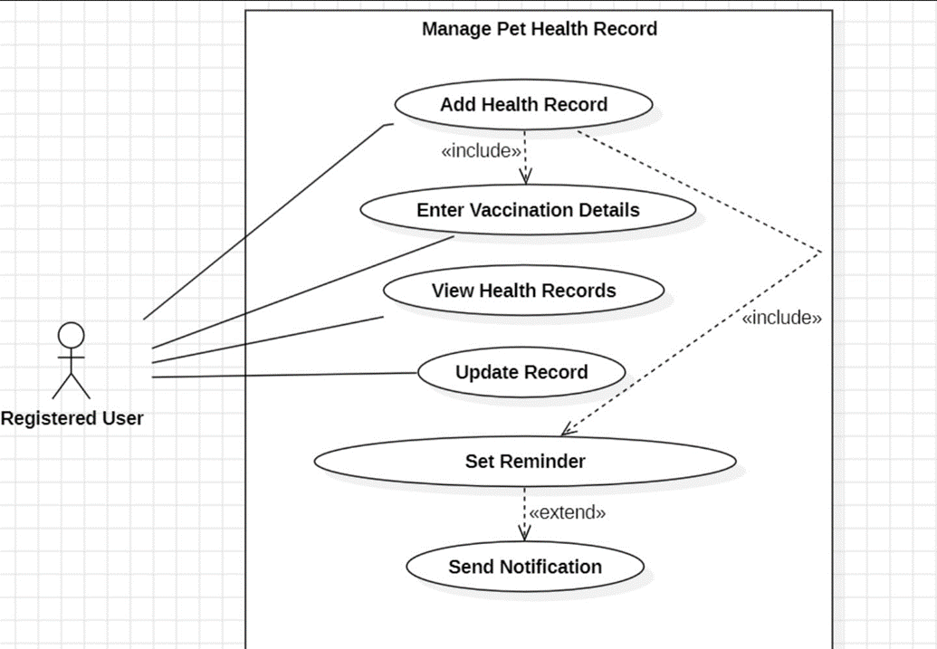
Manage Pet Health Records

Interact With AI Chatbot
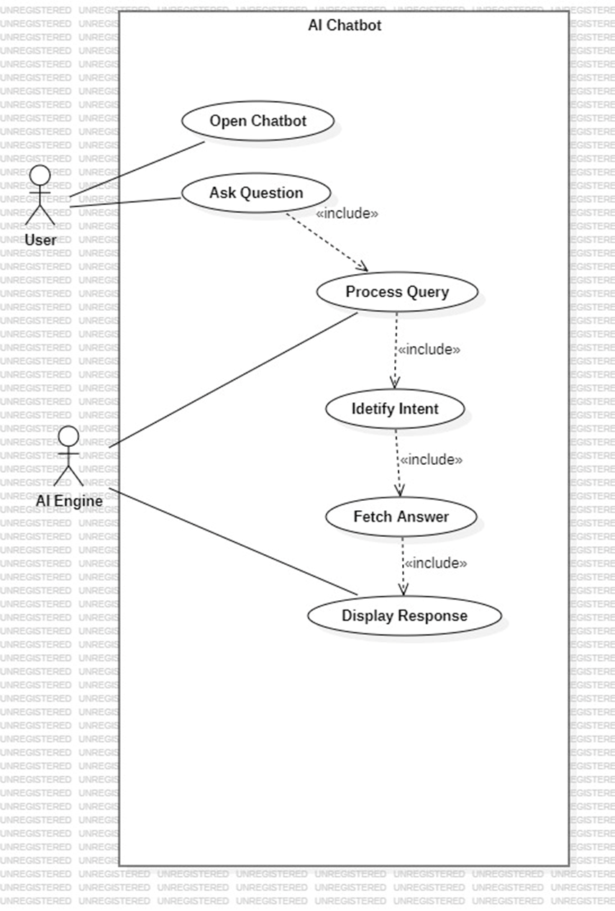

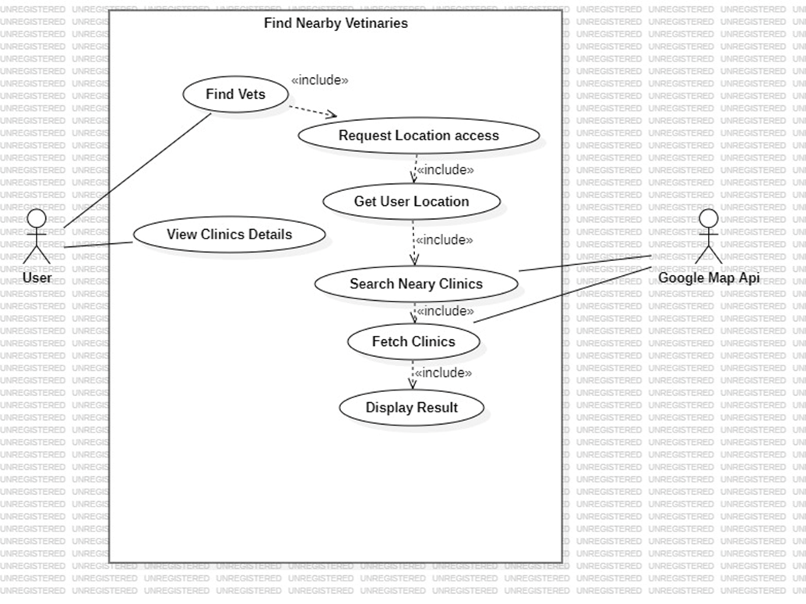
Find Nearby Veterinary Clinics

Admin Store Management Diagram
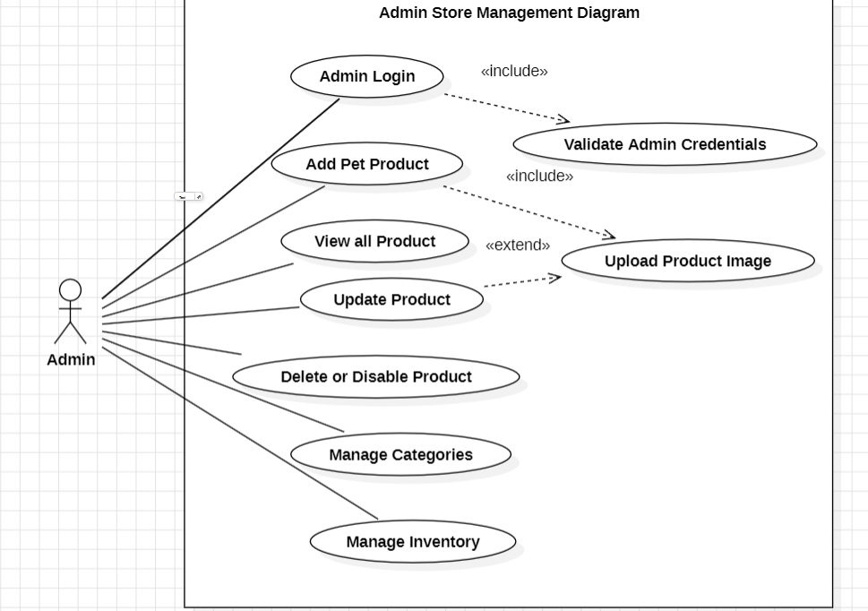

Non-functional Requirements

Reliability

Reliability ID | Description
NFR-REL-01 | The PetLink platform shall maintain at least 99% operational uptime during normal usage conditions.
NFR-REL-02 | The system shall automatically create daily database backups to prevent data loss.
NFR-REL-03 | In case of server or application failure, the system shall recover core services within a reasonable recovery time.
NFR-REL-04 | The system shall preserve data integrity during concurrent user operations and database updates.
NFR-REL-05 | If external APIs (e.g., Google Maps or Payment Gateway) become unavailable, the system shall display appropriate fallback error messages instead of crashing.
NFR-REL-06 | The notification system shall retry failed email or push notifications automatically when possible.

Performance

Performance ID | Description
NFR-PER-01 | The client platforms (React web and React Native mobile apps) must resolve and display initial home viewport configurations within 3 seconds on standard connections.
NFR-PER-02 | The Node.js API ecosystem must reply to data queries within a threshold of 500ms for 95% of execution loops (excluding external sandbox transaction handshakes).
NFR-PER-03 | The persistence architecture must support 50 operational concurrent connections during localized demonstration testing without structural lag.
NFR-PER-04 | The conversational AI assistant engine must parse input data and render initial tokens inside a 2–3 second conversational window.

Use-ability

Usability ID | Description
NFR-USA-01 | The user interface shall remain consistent across both web and mobile platforms.
NFR-USA-02 | Users shall be able to complete core actions such as login, pet listing, and checkout without technical assistance.
NFR-USA-03 | The system shall provide meaningful validation and error messages for invalid inputs.
NFR-USA-04 | Navigation menus and workflows shall remain intuitive and easy to understand for first-time users.
NFR-USA-05 | The platform shall support responsive layouts for different screen sizes and mobile devices.

Other Non-functional Requirements
Security:
- All communication must be encrypted using HTTPS (TLS 1.2 or higher).
- User passwords must be hashed and salted using bcrypt before storage.
- Authentication managed via stateless JWT with appropriate expiry times.
- All user inputs validated and sanitized server-side to prevent injection attacks.
- PetLink backend will never store sensitive credit card details; payment handled by sandbox gateway
Maintainability:
The codebase must be well-structured, commented, and follow consistent naming conventions to facilitate future updates and bug fixes.
Scalability:
The database schema and backend architecture must support future scaling including additional servers, features, and increased user load.
Interoperability:
The backend API must be platform-agnostic, serving both the React web app and React Native mobile app effectively.

Scrum Activities Plan
This section describes how Scrum activities will be executed throughout the PetLink development lifecycle.

Daily Scrum:
The team will conduct short daily stand-up meetings through WhatsApp or in-person sessions lasting approximately 10–15 minutes. During each meeting, every team member will discuss:
- What tasks were completed yesterday?
- What tasks will be worked on today?
- Are there any blockers or issues affecting progress?
Sprint Review:
At the end of each 2-week sprint, the team will demonstrate completed features to the Product Owner (supervisor) for review and feedback.
Sprint Retrospective:
After each sprint review, the team will conduct a retrospective to discuss what went well, what can be improved, and action items for the next sprint.

Kanban Board / Task Tracking
Task tracking will be done using Jira with the following task states:
Kanban Board

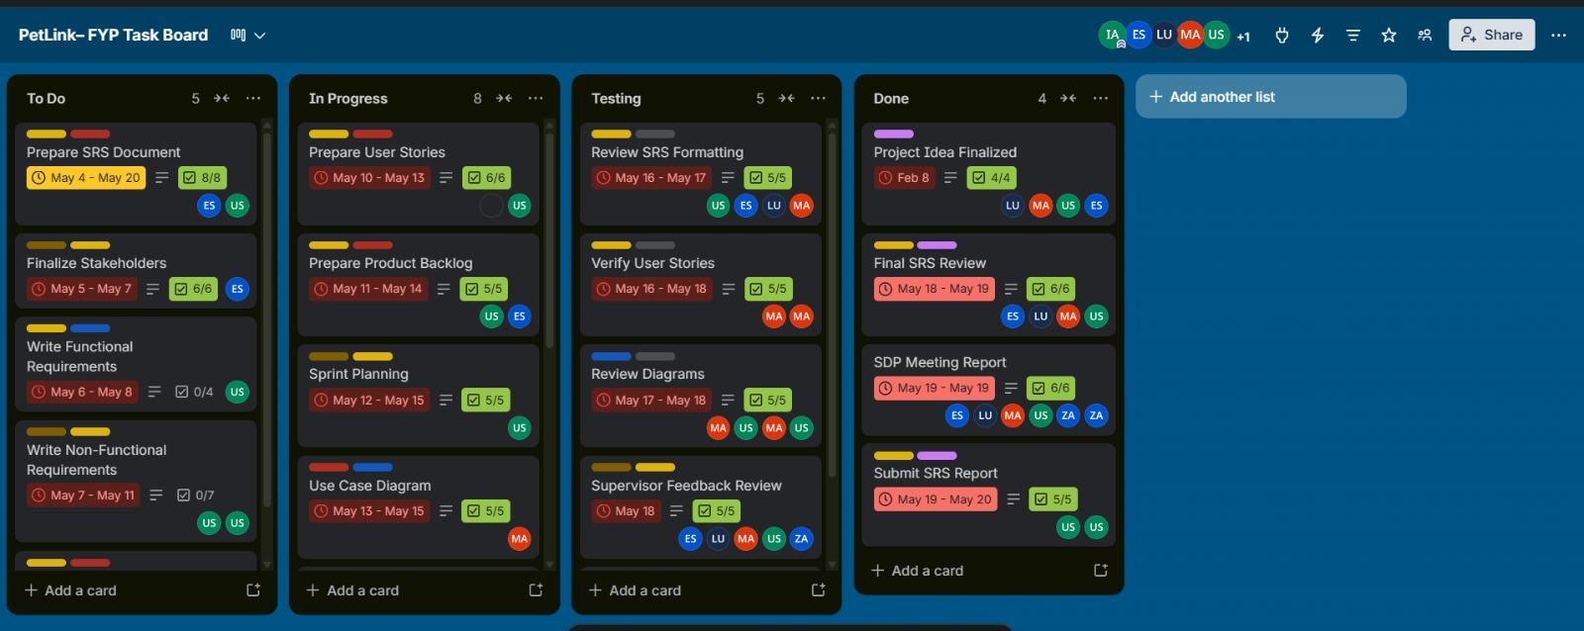

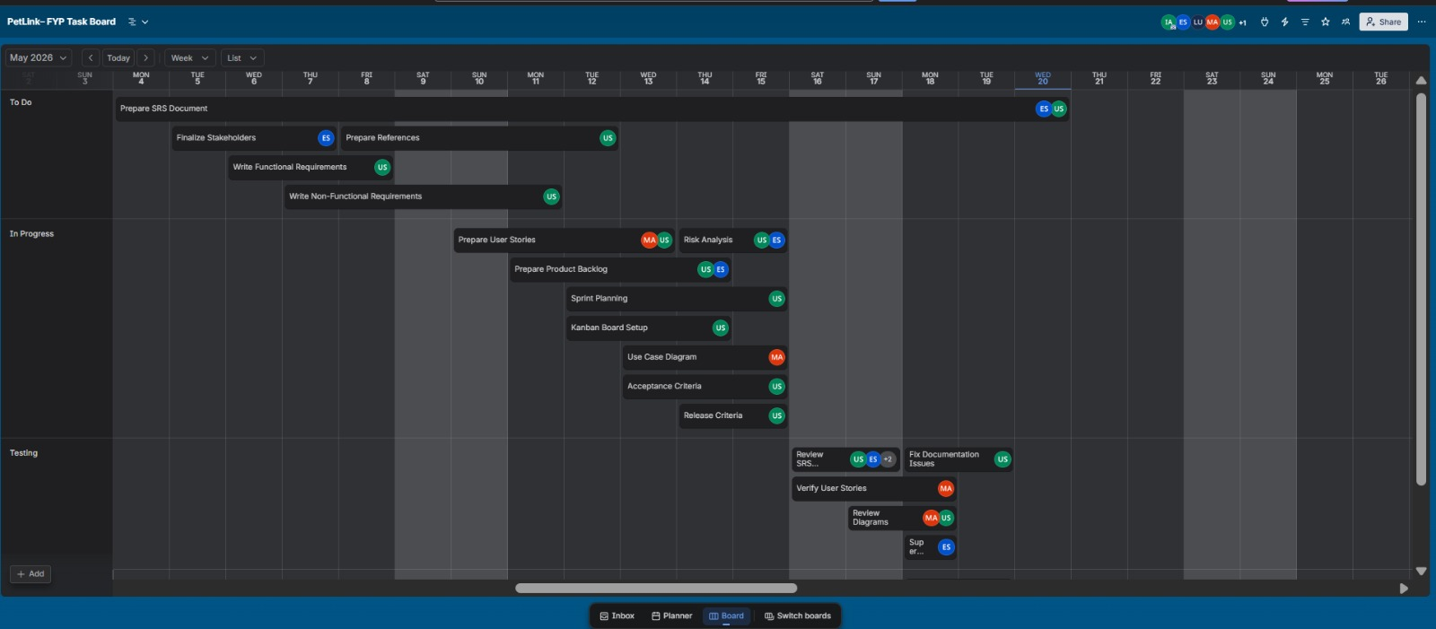
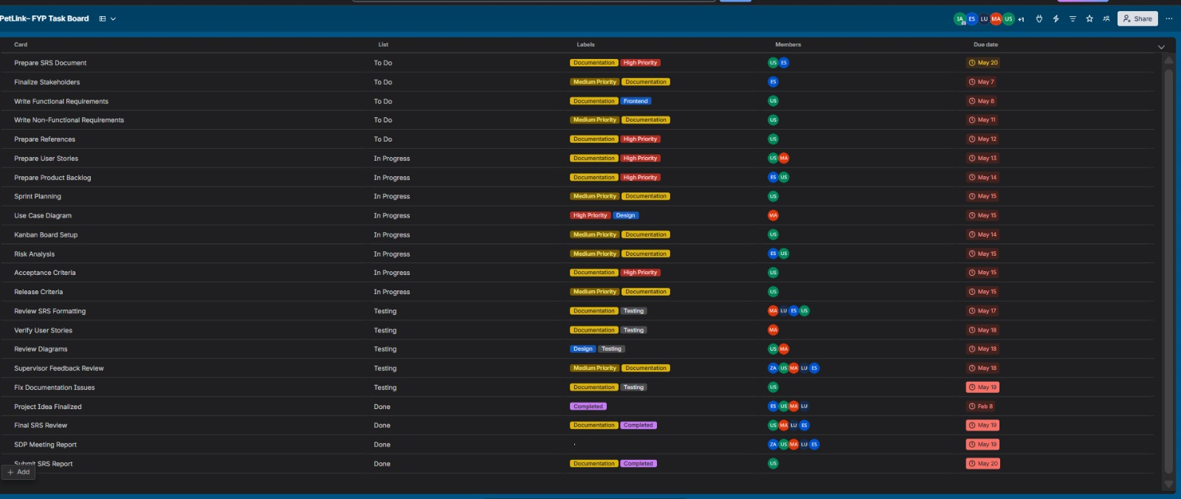

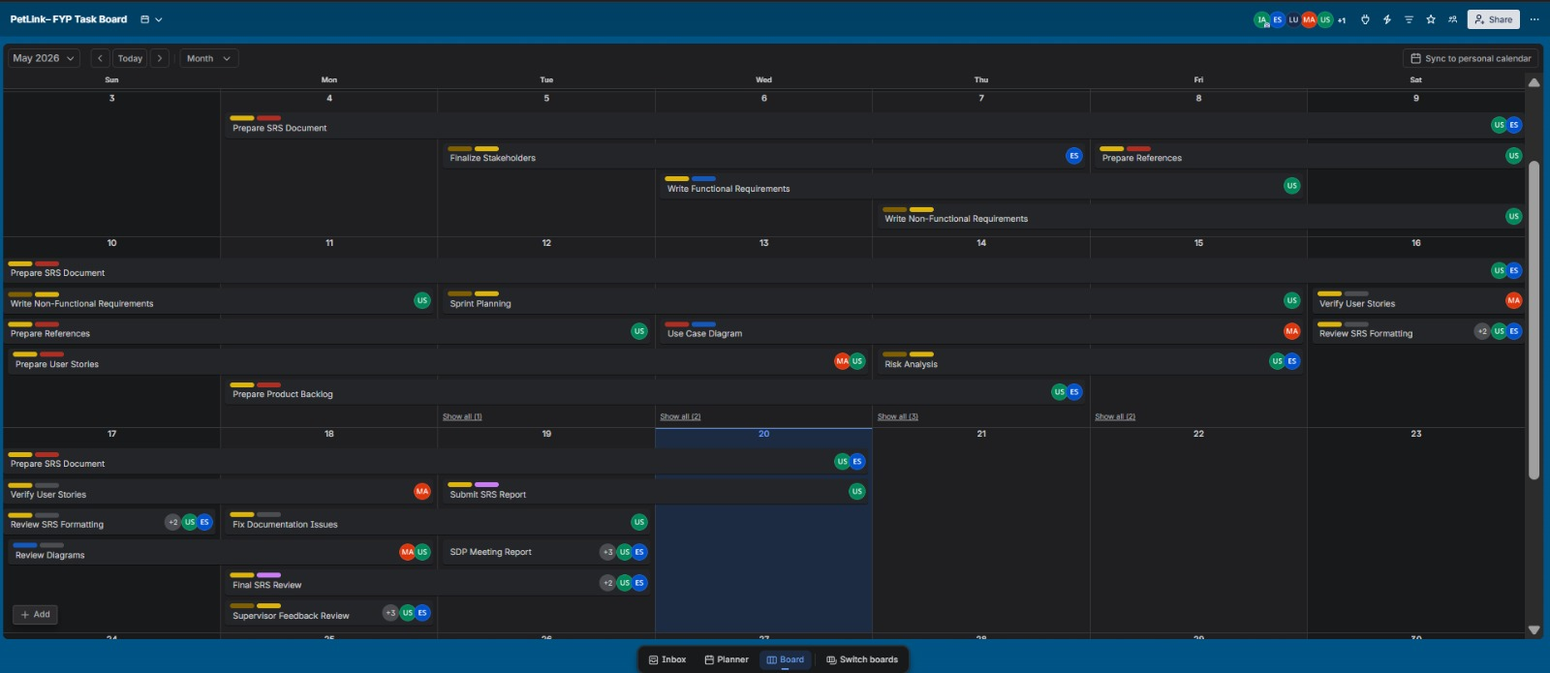

Acceptance Criteria
Each user story must meet its defined acceptance criteria before being marked as Done. Test scenarios will be aligned directly with user stories and functional requirements. Each feature will be tested for:
- Correct functionality under normal conditions.
- Proper error handling and validation messages.
- Performance and load behavior within defined thresholds.
- Security validation (e.g., unauthorized access prevention).

Release Criteria
A sprint release will only be approved if the following conditions are met:
- All sprint user stories have been implemented and passed acceptance testing.
- No critical or high-severity bugs remain unresolved.
- Code reviewed and merged to the main branch on GitHub.
- Product Owner (supervisor) has reviewed and approved the sprint demo

Burndown Chart & Progress Tracking
Progress will be tracked by using a burndown chart maintained in Jira. The expected burn rate is approximately 12–17 story points per sprint. At the end of each sprint, the remaining story points will be compared against the ideal burn line to monitor project health and adjust workload accordingly.

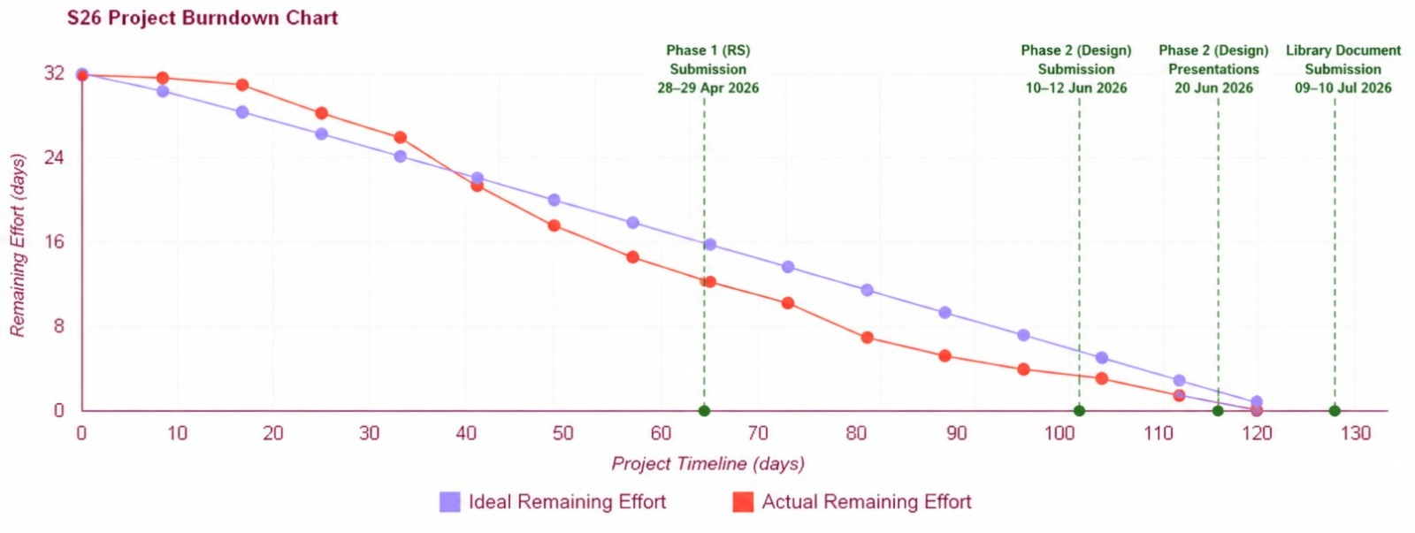

Backlog Refinement Plan
The product backlog will be reviewed and refined at the beginning of each sprint. The process includes:
- Reviewing upcoming user stories for clarity and completeness.
- Re-estimating story points if scope has changed.
- Adding new items discovered during development or supervisor feedback.
- Reprioritizing items based on project progress and deadlines.

Risk Analysis

Risk ID | Risk Description | Category | Impact | Mitigation Strategy
R-01 | AI Chatbot failing to  understand user queries  accurately. | Technical | High | Use pre-defined intents and fallback  responses; extensive testing of common  queries.
R-02 | Inconsistent experience  between Web (React.js) and  Mobile (React Native)  apps. | Technical | High | Share business logic via shared API;  conduct cross-platform testing in each  sprint.
R-03 | Payment gateway sandbox  environment unavailability  or API changes. | Technical | Medium | Use well-documented gateway (Stripe);  maintain fallback mock payment flow.
R-04 | Time constraints due to  managing dual front-ends  and complex backend. | Team | High | Strict sprint planning; assign clear  ownership; prioritize core features first.
R-05 | Google Maps API quota  exceeded or unavailable. | External | Low | Monitor API usage; implement  caching; vet locator is lower priority  feature.
R-06 | Security vulnerabilities in  user authentication or  payment module. | Security | High | Use bcrypt, JWT, HTTPS, input  sanitization; conduct security testing  each sprint.

References
Sommerville, I. (2016). Software Engineering (10th ed.). Pearson Education.

Pressman, R. S., & Maxim, B. R. (2020). Software Engineering: A Practitioner's Approach (9th ed.). McGraw-Hill Education.

React.js Documentation. (2025). React – A JavaScript library for building user interfaces. Retrieved from https://react.dev

React Native Documentation. (2025). React Native – Learn once, write anywhere. Retrieved from https://reactnative.dev

Node.js Foundation. (2025). Node.js Documentation. Retrieved from https://nodejs.org/en/docs
MongoDB Inc. (2025). MongoDB Documentation. Retrieved from https://www.mongodb.com/docs

Google Maps Platform. (2025). Google Maps API Documentation. Retrieved from https://developers.google.com/maps/documentation

Stripe. (2025). Stripe API Reference – Testing. Retrieved from https://stripe.com/docs/testing

Express.js. (2025). Express.js Documentation. Retrieved from https://expressjs.com

Mongoose. (2025). Mongoose ODM Documentation. Retrieved from https://mongoosejs.com/docs/

Khan, S., & Ahmed, R. (2022). Adoption of Digital Platforms in Pakistan. Journal of Information Systems, 14(2), 45-52.

JWT.io. (2025). JSON Web Tokens Documentation. Retrieved from https://jwt.io

OWASP Foundation. (2024). OWASP Top Ten – The Ten Most Critical Web Application Security Risks. Retrieved from https://owasp.org/www-project-top-ten/

Nielsen, J. (1993). Usability Engineering. Morgan Kaufmann.

Pet Industry Market Research. (2024). Pakistan Pet Care Market Report. (Local market insights)
Appendix A: Glossary
AI Chatbot: Conversational AI agent for user assistance.

Backend: Server-side logic, APIs, and database (Node.js + Express.js).

Cross-Platform: Works consistently on web and mobile.

Frontend: Client-side UI (React.js for web, React Native for mobile).

JWT: JSON Web Token for secure authentication.

MERN Stack: MongoDB, Express.js, React, Node.js.

MongoDB: NoSQL document database.

Mongoose: ODM for MongoDB (schema & validation).

NLP: Natural Language Processing for chatbot understanding.

Pet Profile: Digital record of pet details (name, breed, health, etc.).

Product Owner: Defines requirements & priorities.

React.js: Web UI library.

React Native: Mobile app framework (iOS/Android).

Scrum Master: Facilitates Scrum processes.

Sprint: Time-boxed iteration.

SRS: Software Requirements Specification (this document).

Stripe: Payment gateway for online transactions.

UC (Use Case): User interaction description for a goal.

UI/UX: User Interface / User Experience design.

User Story: “As a [user], I want [feature] so that [benefit]”.

Vaccination Record: Digital health record with reminders.
Appendix B: IV & V Report
(Independent verification & validation)
IV & V Resource

Name Signature
Nabeel Ijaz
Ehsan Shahid

S# | Defect Description | Origin Stage | Status | Fix Time
 |  |  |  | Hours | Minutes
1 | Missing User Research data (Survey/Interview results) in section 1.1 | SRS Drafting | Fixed | 2 | 30
2 | Inconsistent numbering of Use Cases in old document | SRS Drafting | Fixed | 2 | 15
3 | Some User Stories lacked proper Acceptance Criteria | SRS Drafting | Fixed | 3 | 50
4 | Non-functional requirements were not mapped properly to the new template sections | Template Migration | Fixed | 1 | 45
5 | Missing Story Points estimation for several user stories | Agile Section | Fixed | 2 | 30
Table 3: List of non-trivial defects

